8.2 Day 1 Review
1. What is the structure of DNA called?
2. What is the following picture of?
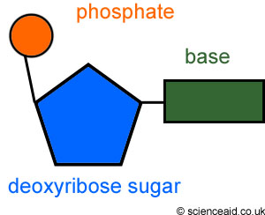
3. How many nucleotides do we have?
4. Apply base pairing rules to the following DNA sequence: TAGCTAGG

